**Calculating Band Offset between Rutile and Anatase Titanium Dioxide by Three-step Method**

Authors

Key Laboratory for Computational Physical Sciences (MOE), State Key Laboratory of Surface Physics, and Department of Physics, Fudan University, Shanghai 200433, China

**ABSTRACT**

The greatest difficulty in calculating the band offset between rutile and anatase TiO2 is that there is no way to construct perfect interface between those two phases. Here, an intermediate phase TiO2II is applied to construct rutile(101)//TiO2II(001) and TiO2II(100)//anatase(112) heterostructures which match perfectly. The band offset among all those phases is calculated with the reference of core-state energy and further refined by the three-step method we developed. It is found that a type-II, staggered band alignment is formed, and the valence band maximum of rutile is 0.8 eV above that of anatase. So in a mixed system the holes are accumulated in the former while the electrons in the later. Our results help to explain the robust separation of photo excited carriers between the two phases.

1. **Introduction**

Titanium dioxide (TiO2), as one important material, can be widely used in from solar cells to photocatalyst and pigmentation1-6. In the past several decades, the tremendous amount of experimental and theoretical research has been performed in studying its photoactivity since Fushijima and Honda discovered the photoelectrochemistry (PEC) effect on anode TiO2 in 1971 7. There are many different polymorphs of TiO2. Rutile, anatase and brookite are the three most common polymorphs. Rutile and anatase have wide band gap of 3.2 and 3.0 eV, respectively, which leads to low absorption efficiency in the solar emission spectra 8. It has been a long standing puzzle that single crystal single crystal rutile and anatase have poorer photocatalytic property than the mixed-phase TiO2 [9-11](#_ENREF_9" \o "Bickley, 1991 #81). Besides the intrinsic nature itself, the interface is of great importance to the photocatalytic property of the mixed phase. The nature band offset between semiconductor compounds is a vital parameter in the interface design because it determines the charge transfer, transport, chemical activity and dopablity of a material.

Large efforts have been made to determine the band offset between rutile and anatase both experimentally and theoretically. Through electrochemical impendence analysis, Kavan *et al*. 12 find that the conduction band of anatase is 0.2 eV above that of rutile (Type-II rutile). This kind of band offset would cause the transfer of holes from rutile to anatase, which is also observed in different experiments.13,14 However, recent X-ray photoemission experiment shows that the conduction band of anatase is 0.2 eV below that of rutile (Type-II anatase) 15. Hence, the issue of the band offset between rutile and anatase is still under debate experimentally. Computational approach have been applied to end this debate, but it is also difficult to obtain the band offset between rutile and anatase directly because it is not possible to construct a hetrostructure interface that preserves the bulk structures on the both sides of the interface. People tried to use other newly developed methods to calculate the band offset, such as the branch point energy (BPE) method, passivated quantum dot (QD) method, and quantum-mechanical/molecular-mechanical (QM/MM) method15-17. The result calculated by the BPE approach is questionable because it only takes the bulk band structure into account, and the number of bands used in such a calculation is not very well defined. In QD calculations, because the core-level energy is sensitive to the local environment of atoms, one should build a supercell large enough to insure the convergence of core-level energy and passivate the surface dandling bonds carefully, which evolve huge amount of calculation. The band offset between rutile and anatase measured or calculated are all listed in table 1, and the different results between experiment and calculation left the issue still under debate.

Inspired by the debate, one may conceive that better construction of the interface between the different phases is likely to improve the reliability of calculation. In this paper, we use a high pressure phase, α-PbO2-like form (TiO2II), as the key intermediate phase in between rutile and anatase. The interface between rutile(101)//TiO2II(001) and TiO2II(100)//anatase(112) makes perfect match18. After the construction of the interface, we apply a more accurate three-step method to calculate the band offset between rutile, TiO2II and anatanse. A more accurate rutile/anatase band offset can be obtained by this approach and help us to look inside to the properties in the mixed phase.

1. **Methods**
   1. **Three-step method for band offset calculation**

Following the procedure in the X-ray photoemission spectroscopy method, which is a commonly used method to measure the band offset experimentally, Wei and Zunger developed an algorithm in which the valance band offset between two hypothetical componds *L* and *R* is calculated by19

where and are the energy separation from the core level to the valence band maximum (VBM) of the corresponding materials, which can be obtained by bulk calculation; and is the energy difference in core levels of the two materials (C and C*) under a common energy reference, which is calculated using the deep lying core states from the calculation of an (L/R) (001) hetrojunction supercell. Here, the core level on each side of the hetrojunction is assumed to preserve their value in the bulk, neglecting the influence from the volume deformation to the core level, which is only suitable for systems with negligible lattice mismatch. In order to apply this method to systems with larger lattice mismatch, we proposed a new method called “there-step method” [unpublished]. In the first step, L is expended alone the (100) direction by , which is denoted as L’ with lattice constant (b1, a2, a3). is the core level difference between L and L’, which can be obtained from the calculation of the heterostructure of L/L’ along (100) direction. In the second step, L’’ is constructed from expanding L’ along (010) by , and the core level difference is obtained from the calculation of the heterostructure of L/L’ along (100) direction. In the third step, the core level difference between L’’ and R can be obtained from the calculation of the heterostructure of L’’/R along (001) direction. In three-step method, the valance band offset between two compounds L and R can be calculated by

It has been proved that the results of three-step method is reasonable, the valance band offsets of Si/Ge (~0.68 eV) and GaAs/InAs (~0.41 eV) are in good consistence with previous experimental and theoretical studies.

* 1. **Calculation details for TiO2 system**

In this work, we use density functional theory (DFT) method for structural relaxation and electronic structure calculation. The ion-electron interaction is treated by the projector augmented-wave (PAW) technique 20, as implemented in the Vienna ab initio simulation package (VASP) 21. The exchange-correlation potential is treated using the Perdew-Burke-Ernzerhof (PBE)22 functional. The basis set cutoff is 500 eV. The 3D k-mesh is generated by the Monkhorst-Pack scheme, where the density of k-points is approximately 0.04 Å-1.

**Results and discussion**

One of the greatest difficulties in calculating the band offset between rutile (R) and anatase (A) TiO2 is that it is almost impossible to construct a heterostructure interface because there is no surface with common lattice constant between the two structures. However, the local structure of interface is critical in band offset investigation because electric field or defect states induced by interface may affect the result of calculation. From a recent study of the transition pathway from rutile to anatase, TiO2II (II) serves as a key intermediate.18 Both rutile and anatase can match TiO2II perfectly. The lattice constants and space group of rutile, anatase and TiO2II are listed in table 2, and the structures are plotted in figure 1 (a-c). The rutile (101) surface has a surface cell size of 4.62 Å ╳ 5.48 Å, and we expend it to be 4.58 Å ╳ 4.59 Å (R’ phase) to match TiO2II (001) surface, to construct a heterostructure of rutile(101)/TiO2II(001) (R’(101)/II(001)) (figure1d). The anatase (112) surface has a surface cell size of 5.37 Å ╳ 5.57 Å, and we expend it to be 4.93 Å ╳ 5.57 Å (A’ phase) to match TiO2II (100) surface to construct anatase(112)/TiO2II(100) (A’(112)/II(100)) (figure 1e). All the heterostructure models we built are electrically neutral and stoichiometric.

The band offset of R’/II and A’/II can be calculated by core-level alignment equation (1) 19, which are denoted as and , respectively. The valence band offset between R and R’ (A and A’) is calculated by the three-step method which we developed recently which result is (). The computational progress is schematically shown in figure 2. It should be noted that all the band offsets calculated by the chosen methods satisfy the transitivity relation, which means that if the band offsets of A/B and A/C are known, then B/C can be inferred with good accuracy. Finally we can obtain the band offset between rutile and anatase by the follow formula:

(3)

From the calculation we conclude that the valance band edge of rutile lies about 0.8 eV above that of anatase, while the conduction band offset is about 0.6 eV. Schematic of the band offset between rutile and anatase TiO2 is shown in figure 3. This staggered type-II aliment of the bands means that migrating holes accumulate in rutile, while electrons in anatase. The charge separation across the rutile/anatase interface could be an important reason why the mixed phase of rutile and anatase is observed to exhibit higher photovoltaics and photocatalysis than their pristine phases.

In order to investigate why there is 0.8 eV band offset between rutile and anatase, we used HSE06 to calculate the electronic density of states of rutile, anatase and TiO2II, which are shown in figure 3. According to the common anion rule alignment23, the valance band offset should be small between oxides, except that cation orbitals contribute to the valance band. However, the valance band edge of all the three materials is dominated by O 2*p*. The valance parts of DOS are similar among the three phases of TiO2, except that there is a “tail” at the top of the valance band of rutile. To further understand this exception, Wannier function has been applied. The top most of valance band of all the three phases are composed of *pz*-like orbital of O atoms, which are perpendicular to the Ti-O bond plane, as shown in figure 5. The *pz*-like orbital do not participant in the Ti-O bond, and can be interpreted as lone-pair. The “tail” in rutile can be interpreted as strong overlap between the O *pz*-like orbital compared to those in anatase and TiO2II.

Conclusion

In summary, we find an intermediate phase TiO2II between rutile and anatase to construct perfect interface of rutile(101)/TiO2II(001) and anatase(112)/TiO2II(100), and the band offsets among rutile, TiO2II and anatase are calculated with the reference of core-state energy. Further refinement of the band offset calculation is made by three-step method that we developed recently. The result of the calculation reveals a staggered energy band alignment between rutile and anatase, with the valence band maximum of rutile at about 0.8 eV above that of anatase, which supports the previous study by Deák *et al*. 16, Pfeifer *et al*. 24 and Scanlon *et al*15. The staggered band offset makes good explanation for the enhanced photovoltaic and photocatalytic activity in the mixed rutile and anatase TiO2 as it provides a driving force for separation of charge carriers.

Acknowledgement

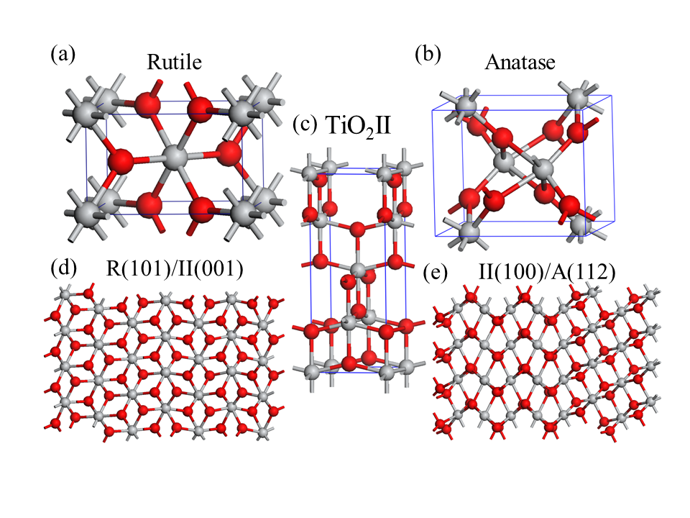

Figure 1 DFT optimized bulk phase structures for (a) rutile, (b) anatase and (c) TiO2II and heterostructure for (d) rutile(101)/TiO2II(001) and (e) TiO2II(100)/anatase(112). Gray and red spheres represent Ti and O atoms, respectively.



Figure 2 Schematic alignment procedure used to calculate the natural valance band offsets for rutile, anatase and TiO2II. The valance band offsets of R/R’ and A/A’ are calculated by three-step method while R’/II and A’/II are calculated by core-level alignment.



Figure 3 Valance and conduction band alignment mechanisms for rutile/anatanse interface. The arrows indicate the flow of electrons (holes) in the conduction band (valence) band.

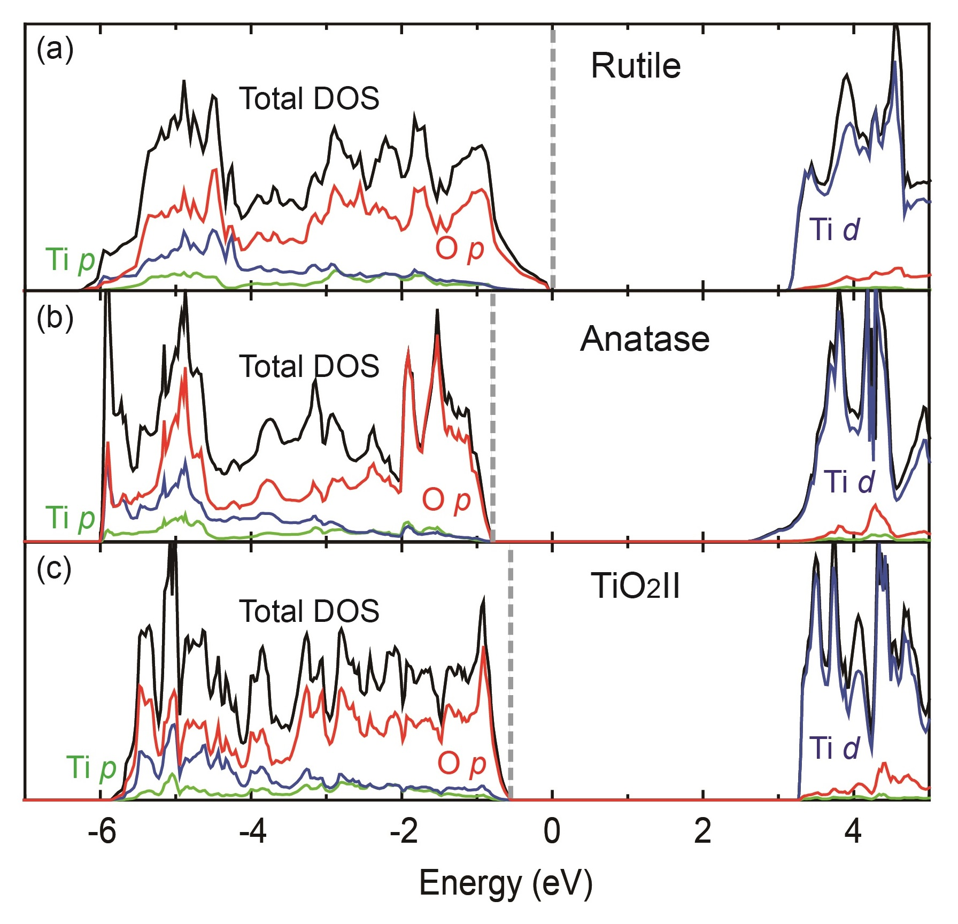

Figure 4 Comparison of the total and ion-decomposed electronic density of states of (a) rutile, (b) anatase and (c) TiO2II calculated by the HSE06 hybrid functional. The valance band maximum is marked by a gray dash line.

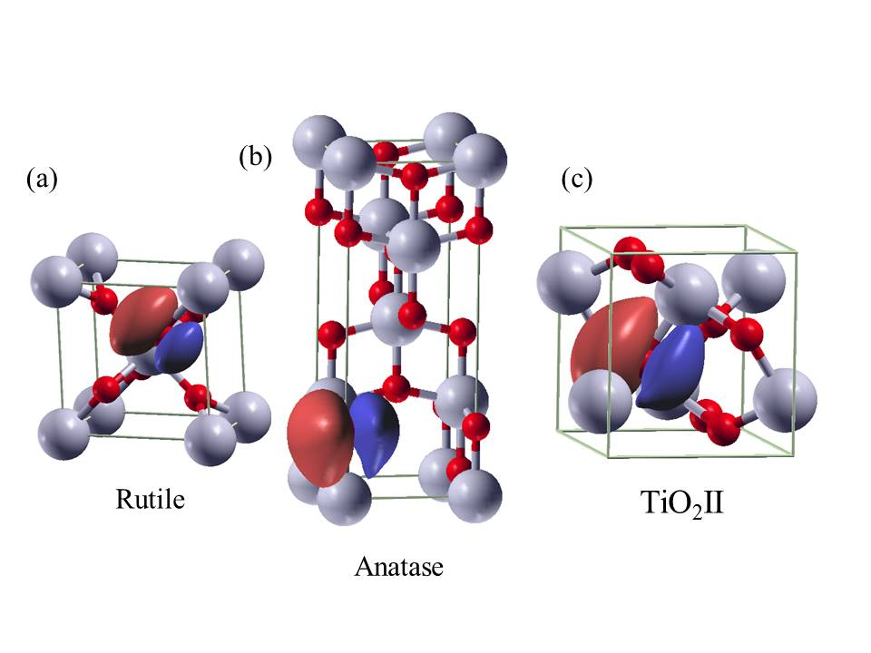

Figure 5 *pz*-like maximally localized Wannier functions for (a) rutile, (b) anatase and (c) TiO2II. The orbital spreads are 1.00 Å2.

Table 1. Band offset between rutile and anatase from experiment or calculation. Our result is marked as red.

|  |  |  |  |  |
| --- | --- | --- | --- | --- |
|  | Year | VBO (eV) | CBO (eV) | Type |
| Theoretical Results | 2011 | 0.55 | 0.35 | II16 |
| 2012 | 0 | -0.2 | I17 |
| 2013 | 0.39~0.47 | 0.17~0.30 | II15 |
| 2013 | 0.63 | 0.39 | II24 |
| 2014 | 0.52 | 0.22 | II25 |
| 2014 | 0.86~0.90 | 0.65~0.69 | II26 |
| 2015 | 0.8 | - | II |
| Experimental Results | 1996 | - | -0.2 | I12 |
| 2007 | 0.2 | - | II27 |
| 2013 | 0.39 | 0.22 | II15 |
| 2013 | 0.60~0.80 | - | II24 |

Table 2 DFT optimized lattice parameters (length in Å) and space group for rutile, anatase and TiO2II.

|  |  |  |  |  |  |  |  |
| --- | --- | --- | --- | --- | --- | --- | --- |
| Name | a | b | c | α | β | γ | Space Group |
| rutile | 4.62 | 4.62 | 2.96 | 90 | 90 | 90 | P42/mnm  (#136) |
| anatase | 3.80 | 3.80 | 9.78 | 90 | 90 | 90 | I41/amd  (#141) |
| TiO2II | 4.58 | 5.59 | 4.93 | 90 | 90 | 90 | Pbcn  (#60) |

(1) Asahi, R.; Morikawa, T.; Ohwaki, T.; Aoki, K.; Taga, Y. *science* **2001**, *293*, 269.

(2) Tao, J.; Luttrell, T.; Batzill, M. *Nat Chem* **2011**, *3*, 296.

(3) Khan, S. U. M.; Al-Shahry, M.; Ingler, W. B. *Science* **2002**, *297*, 2243.

(4) Nikolay, T.; Larina, L.; Shevaleevskiy, O.; Ahn, B. T. *Energy & Environmental Science* **2011**, *4*, 1480.

(5) Choi, W.; Termin, A.; Hoffmann, M. R. *The Journal of Physical Chemistry* **1994**, *98*, 13669.

(6) Chen, H.-Z.; Zhang, Y.-Y.; Gong, X.; Xiang, H. *The Journal of Physical Chemistry C* **2014**, *118*, 2333.

(7) Bak, T.; Nowotny, J.; Rekas, M.; Sorrell, C. C. *International Journal of Hydrogen Energy* **2002**, *27*, 19.

(8) Zhang, H. Z.; Banfield, J. F. *J. Phys. Chem. B* **2000**, *104*, 3481.

(9) Bickley, R. I.; Gonzalez-Carreno, T.; Lees, J. S.; Palmisano, L.; Tilley, R. J. *Journal of Solid State Chemistry* **1991**, *92*, 178.

(10) Ohno, T.; Sarukawa, K.; Tokieda, K.; Matsumura, M. *Journal of Catalysis* **2001**, *203*, 82.

(11) Klionsky, D. J.; Abdalla, F. C.; Abeliovich, H.; Abraham, R. T.; Acevedo-Arozena, A.; Adeli, K.; Agholme, L.; Agnello, M.; Agostinis, P.; Aguirre-Ghiso, J. A. *Autophagy* **2012**, *8*, 445.

(12) Kavan, L.; Grätzel, M.; Gilbert, S.; Klemenz, C.; Scheel, H. *Journal of the American Chemical Society* **1996**, *118*, 6716.

(13) Kawahara, T.; Konishi, Y.; Tada, H.; Tohge, N.; Nishii, J.; Ito, S. *Angewandte Chemie* **2002**, *114*, 2935.

(14) Miyagi, T.; Kamei, M.; Mitsuhashi, T.; Ishigaki, T.; Yamazaki, A. *Chemical Physics Letters* **2004**, *390*, 399.

(15) Scanlon, D. O.; Dunnill, C. W.; Buckeridge, J.; Shevlin, S. A.; Logsdail, A. J.; Woodley, S. M.; Catlow, C. R.; Powell, M. J.; Palgrave, R. G.; Parkin, I. P.; Watson, G. W.; Keal, T. W.; Sherwood, P.; Walsh, A.; Sokol, A. A. *Nat Mater* **2013**, *12*, 798.

(16) Deák, P.; Aradi, B. l.; Frauenheim, T. *The Journal of Physical Chemistry C* **2011**, *115*, 3443.

(17) Kang, J.; Wu, F.; Li, S.-S.; Xia, J.-B.; Li, J. *The Journal of Physical Chemistry C* **2012**, *116*, 20765.

(18) Shang, C.; Zhao, W. N.; Liu, Z. P. *Journal of physics. Condensed matter : an Institute of Physics journal* **2015**, *27*, 134203.

(19) Wei, S.-H.; Zunger, A. *Applied Physics Letters* **1998**, *72*, 2011.

(20) Blöchl, P. E. *Physical Review B* **1994**, *50*, 17953.

(21) Kresse, G.; Hafner, J. *Physical Review B* **1994**, *49*, 14251.

(22) Perdew, J. P.; Burke, K.; Ernzerhof, M. *Physical Review Letters* **1996**, *77*, 3865.

(23) Klein, A. *Thin Solid Films* **2012**, *520*, 3721.

(24) Pfeifer, V.; Erhart, P.; Li, S.; Rachut, K.; Morasch, J.; Brötz, J.; Reckers, P.; Mayer, T.; Rühle, S.; Zaban, A.; Mora Seró, I.; Bisquert, J.; Jaegermann, W.; Klein, A. *The Journal of Physical Chemistry Letters* **2013**, *4*, 4182.

(25) Ju, M. G.; Sun, G.; Wang, J.; Meng, Q.; Liang, W. *ACS Appl Mater Interfaces* **2014**, *6*, 12885.

(26) Kullgren, J.; Huy, H. A.; Aradi, B.; Frauenheim, T.; Deák, P. *physica status solidi (RRL) - Rapid Research Letters* **2014**, *8*, 566.

(27) Xiong, G.; Shao, R.; Droubay, T. C.; Joly, A. G.; Beck, K. M.; Chambers, S. A.; Hess, W. P. *Advanced Functional Materials* **2007**, *17*, 2133.